Objective Questions

- Are there any tables with duplicate or missing null values? If so, how would you handle them?
Generated query to filter all the tables using the IS NULL constraint to check whether any table contains NULL values or not. To check duplicates, the query uses the GROUP BY clause to group all rows by the target column(s) – i.e. the column(s) you want to check for duplicate on.
The output depicts we don’t have any duplicate values or any Null values.
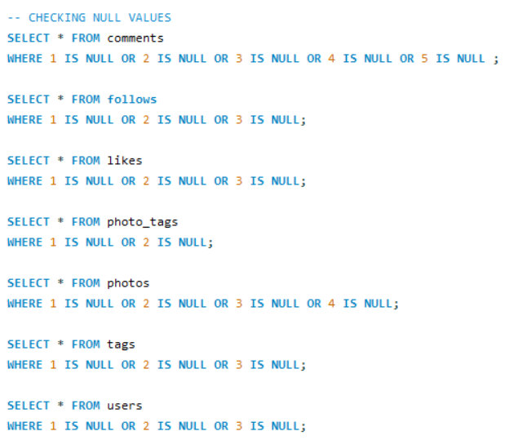
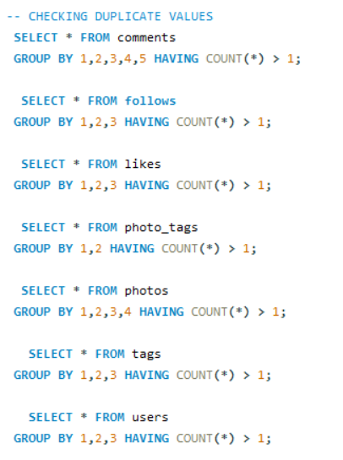

- What is the distribution of user activity levels (e.g., number of posts, likes, comments) across the user base?
Here the query calculated the total count of likes, comment,
and number of posts made by the users from various tables such as photos, likes and comment tables.

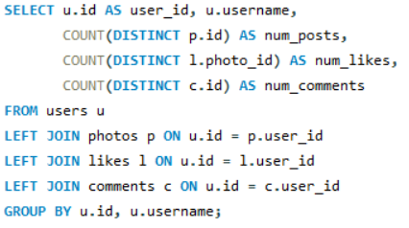

The distribution of user activity according to the likes, comments and number of posts as following

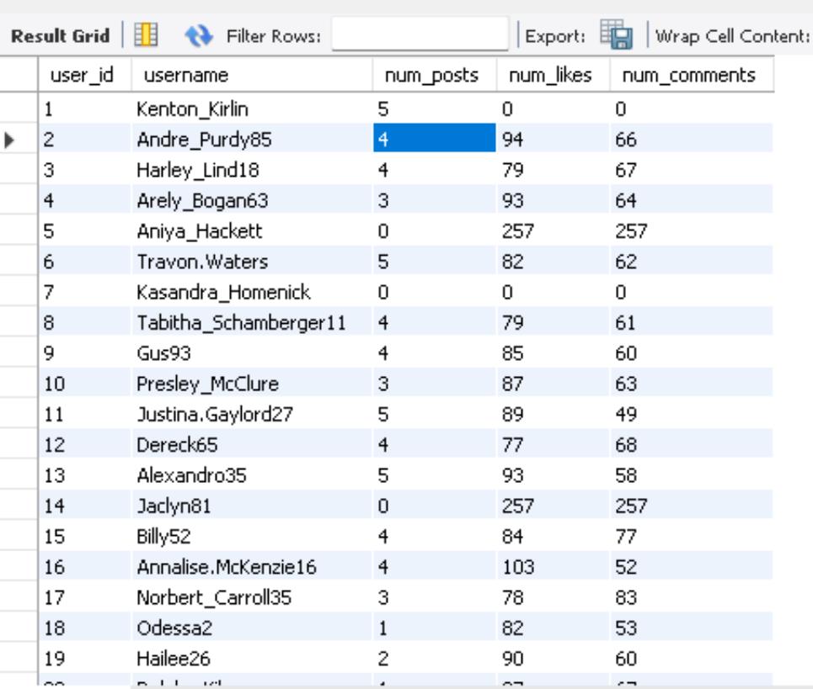

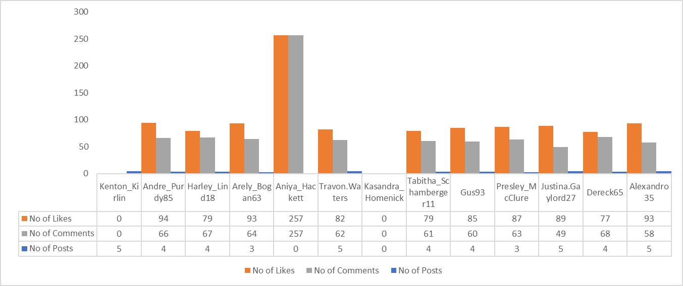

- Calculate the average number of tags per post (photo_tags and photos tables).

On querying the average number of tags per posts and it came 1.9494.

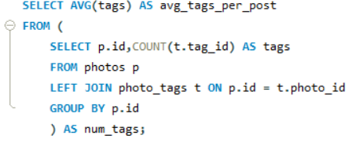

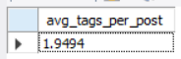

- Identify the top users with the highest engagement rates (likes, comments) on their posts and rank them.

To identify the top users with highest engagement rates, used Subqueries to get the total likes and comments and used them as temporary tables which are then joined with the users table.
Also used COALESCE to handle the NULL values.
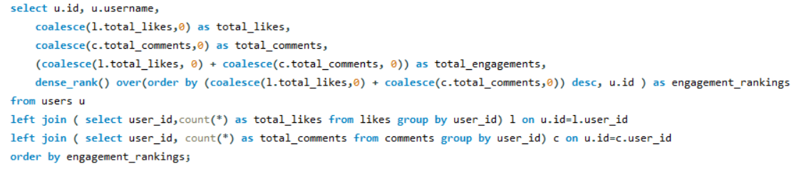

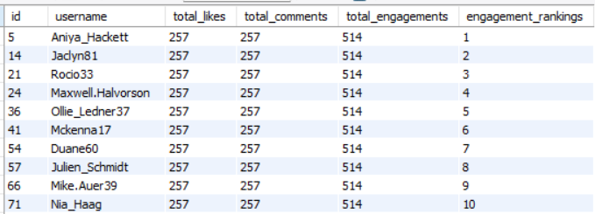
- Which users have the highest number of followers and followings?

In this query I used Subqueries to create tables for finding count of followers_count and followings_count respectively.
Generated output.

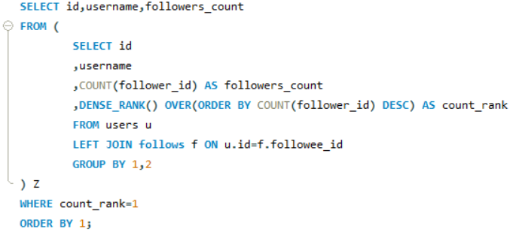

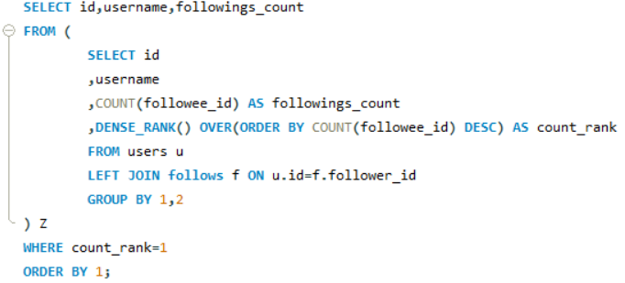

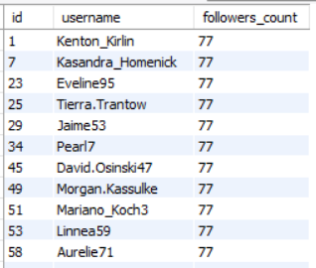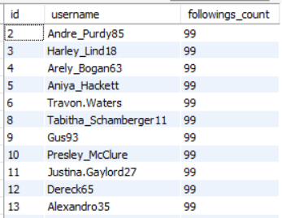

- Calculate the average engagement rate (likes, comments) per post for each user.
In this question calculated the total number of posts, total number of likes and total number of comments for each user using subqueries and joined them in the main query using left joins then in the main query. Later calculated average engagement using formula
(total likes + total comments) / total posts --- for each user

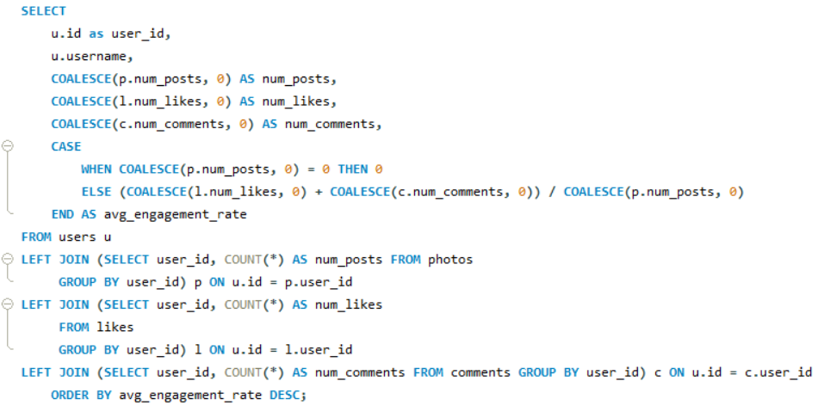

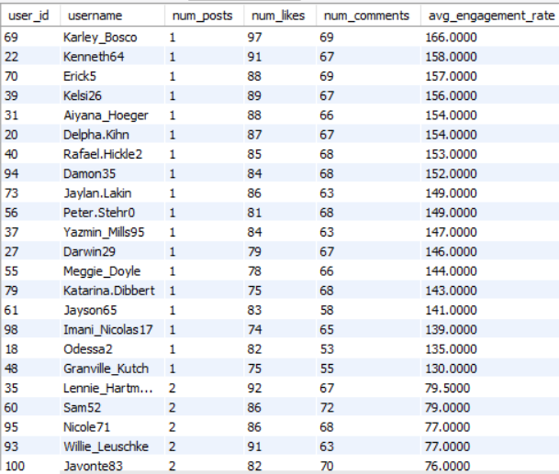

- Get the list of users who have never liked any post (users and likes tables).

Found the id and usernames of those users who haven’t liked any posts by using Set Operations and Subqueries.

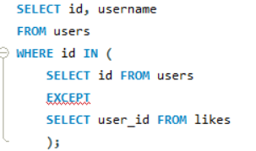

This query gave us the desired output of the list of those users who have never liked any post.

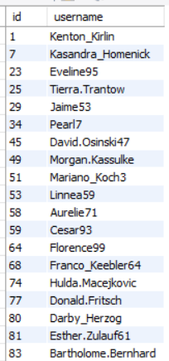

- How can you leverage user-generated content (posts, hashtags, photo tags) to create more personalized and engaging ad campaigns?

- This query calculates the number of likes for photos associated with each tag/category.

- Firstly it categorizes the tags into few categories to get a better understanding of tags.

- Then calculated total likes for each category and ranking them based on number of likes.

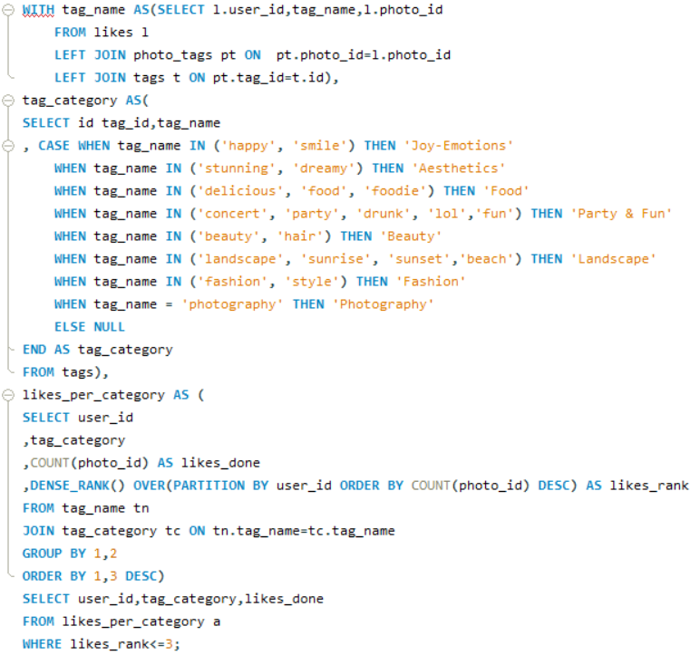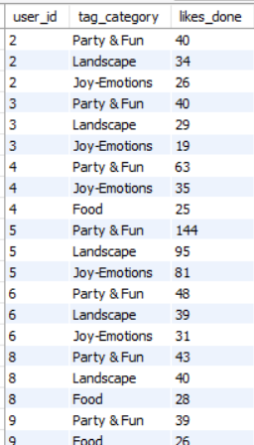

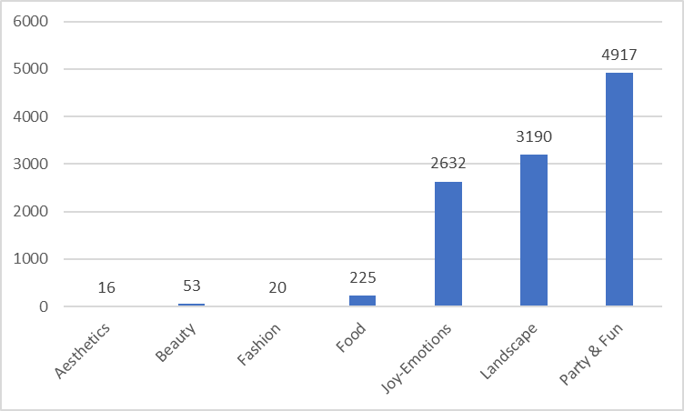

SUGGESTIONS:

      - Analyse User Interests: I would start by identifying popular categories and photo tags to see what themes or topics users are engaging with. This insight allows us to create ads that resonate with these themes, increase engagement.
      - Target Specific Audiences: I’d use data from posts and tags to group users into categories based on their interests and behaviours. This lets us target ads specifically to these groups, increasing the chance they’ll engage with the content.
      - Leverage Social Proof: Featuring user comments, or popular posts in campaigns can build trust and drive conversions. This showcases real user experiences and encourages others to participate, boosting ad effectiveness.
      - Promote Influencers and Power Users: Engaging with users who are particularly active with relevant tags or content can amplify brand reach. Brands can offer these users special incentives or collaborations, letting their authentic voice enhance brand credibility and expand its reach.
      - Keep Ads Updated with Trends: By tracking trending hashtags, I could help keep ads aligned with current trends, ensuring they’re fresh and engaging for the audience.

- Are there any correlations between user activity levels and specific content types (e.g., photos, videos, reels)? How can this information guide content creation and curation strategies?

We can clearly see the correlation between the user activity and their engagement with the photos.

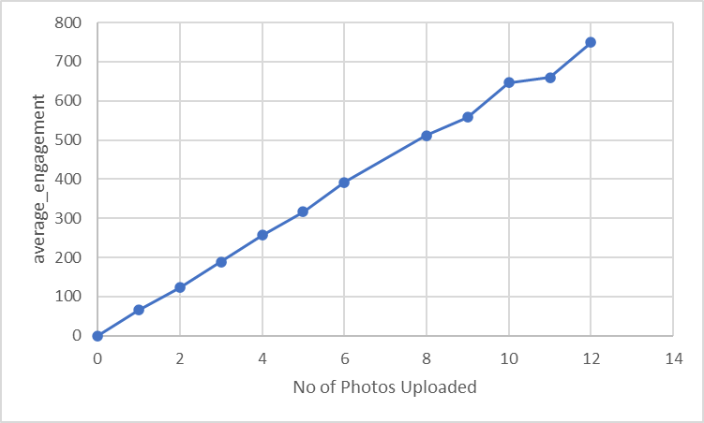

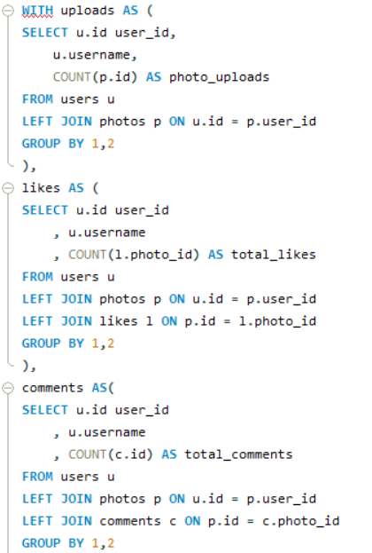

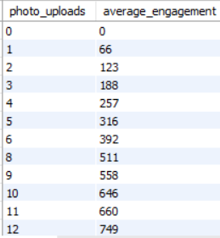
- Calculate the total number of likes, comments, and photo tags for each user.

In this query I utilized subqueries and joins for finding total likes, total comments, total photo tags then joined them to the main query to find the id, username and their respective total likes, total comments, total photo tags.

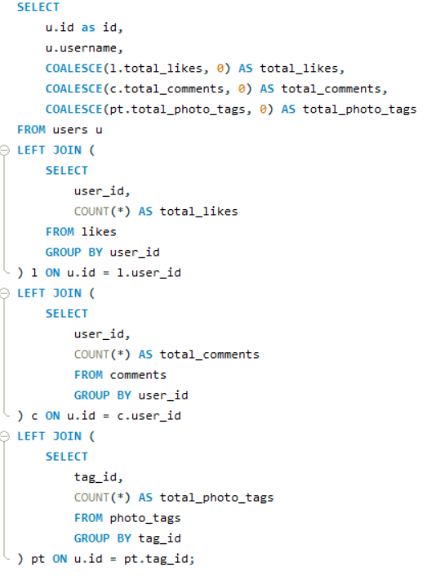

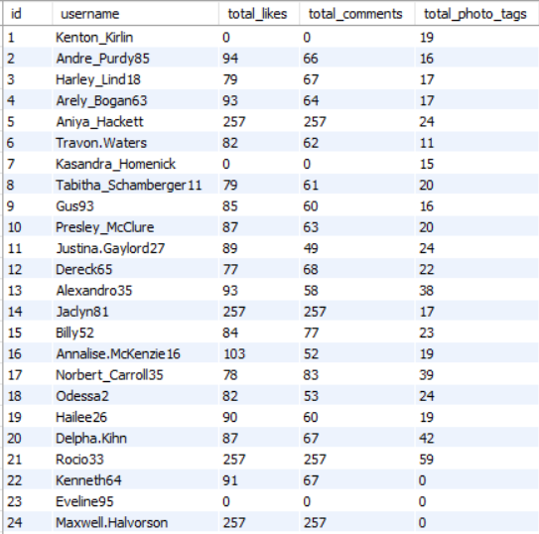

- Rank users based on their total engagement (likes, comments, shares) over a month.

In this Query found the total likes, total comments using cte and added them together to find total engagement for the each month and then in the main query I employed a Dense_rank function to rank the users on the basis of total engagement. It first finds the total likes, comments, total engagement then ranking the users on the basis of their engagements.

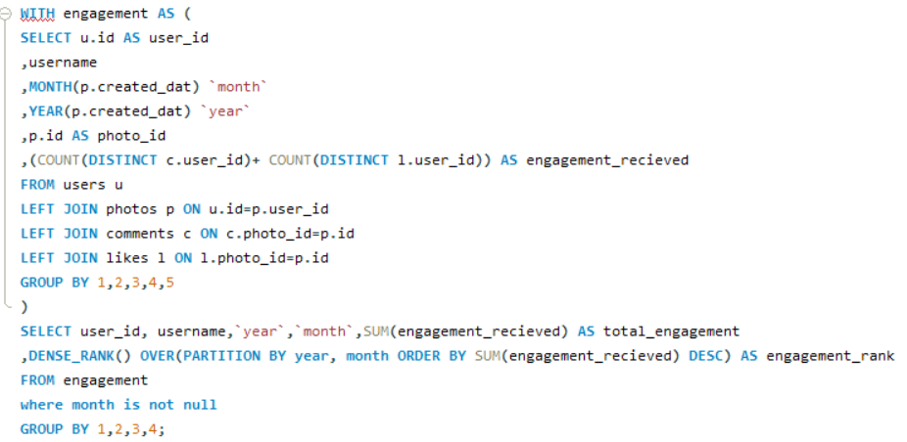
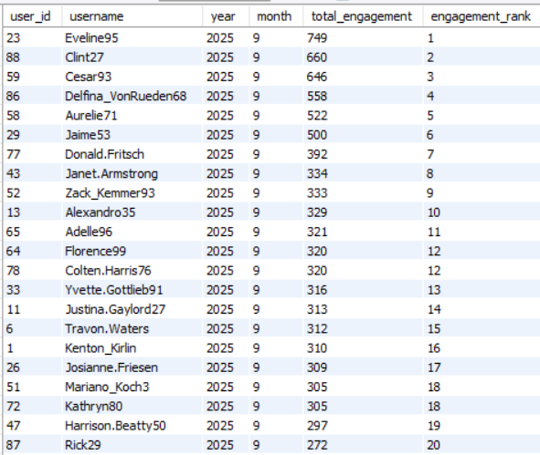
- Retrieve the hashtags that have been used in posts with the highest average number of likes. Use a CTE to calculate the average likes for each hashtag first.

To retrieve the hashtags that have been used in posts with the highest average number of likes. Here I used cte to find total count of likes and the average number of likes for the tag. Then in the main query filtered the tag which has highest average.

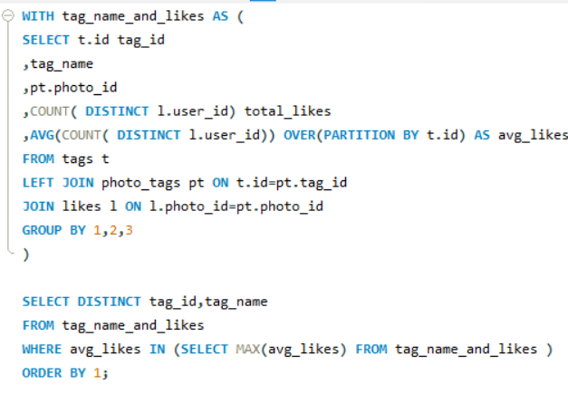

Tag which has the highest number of likes.

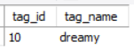

- Retrieve the users who have started following someone after being followed by that person.
In this question in order to retrieve the users who have started following someone after being followed by that person I employed a Query where I used the created_at column to compare the followee_id and follower_id whichever was created before. But didn’t find any such record proving there is no such kind of users.
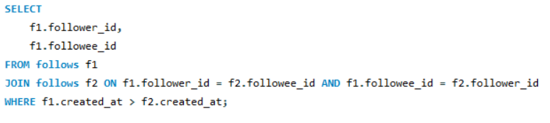
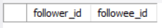

Subjective Questions

- Based on user engagement and activity levels, which users would you consider the most loyal or valuable? How would you reward or incentivize these users?

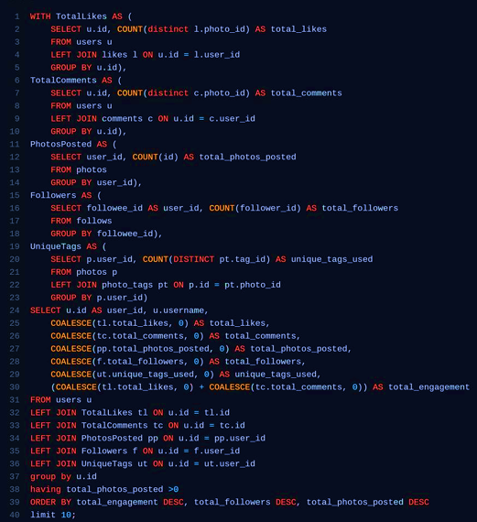

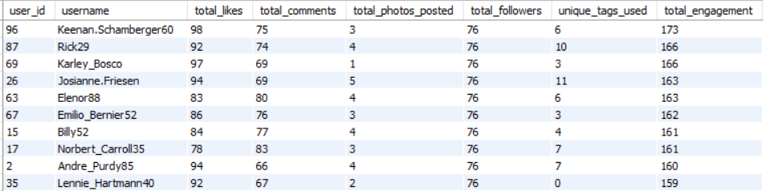

INSIGHTS:
a) Top Contributors Identified: By analysing user activity data, we identified the top 10
users who consistently engage with the platform through posts, likes, and comments.
b) High Engagement = High Loyalty: Users with the highest number of likes and comments
demonstrated strong engagement, suggesting they are more loyal and invested in the
platform’s content.
c) Activity Distribution: Among total activities, likes and comments formed the majority of
user engagement, highlighting the importance of interactive features over just content
creation.
d) Consistency Over Time: Regular activity, not just one-time participation, was a key factor
in determining loyalty, ensuring that the selected users are not just one-time contributors.

RECOMMENDATIONS:
a) Reward Loyalty: Consider implementing a loyalty or recognition program (e.g., badges,
leaderboard, or exclusive access) for the top 10 most engaged users to maintain and
increase motivation.
b) Encourage Broader Engagement: Promote interactive features like liking and
commenting by adding gamified incentives to encourage less active users to participate
more.
c) Track Engagement Trends: Continuously monitor user engagement through similar
metrics to identify rising contributors early and nurture them.
d) User Segmentation: Create user segments based on engagement levels to send
targeted content, rewards, or campaigns to each group accordingly.
e) Enhance Community Features: Improve or expand community-driven features (e.g.,
discussions, replies, mentions) as these drive both engagement and loyalty.

- For inactive users, what strategies would you recommend to re-engage them and encourage them to start posting or engaging again?

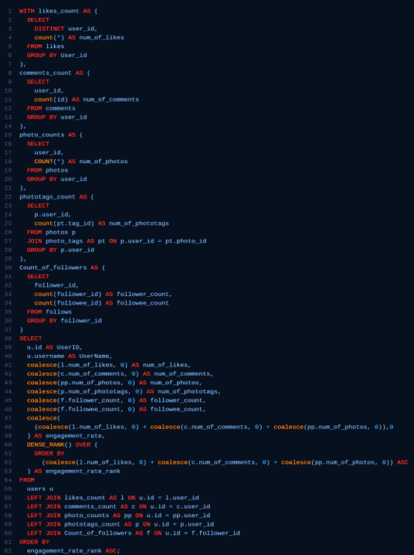

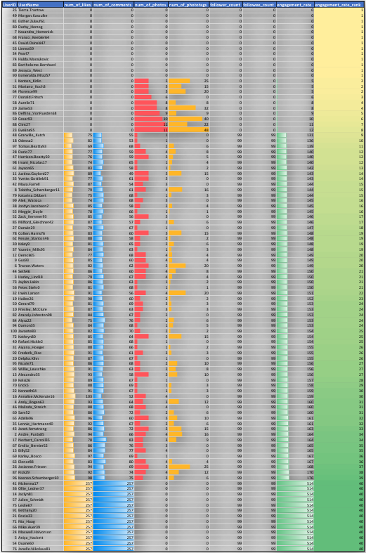

The query calculates user engagement metrics on a platform, including likes, comments, photos, photo tags, and follower counts.
Common Table Expressions (CTEs):

1. likes_count: Counts likes per user.
2. comments_count: Counts comments per user.
3. photo_counts: Counts photos per user.
4. phototags_count: Counts photo tags per user.
5. Count_of_followers: Counts followers per user.
6. Joins each CTE with the users table using LEFT JOIN to include all users, even those
without specific activities.
7. Uses COALESCE to replace NULL values with zero.
8. Calculated an engagement_rate as the sum of likes, comments, photos.
9. Then ranked users by engagement_rate in ascending order using DENSE_RANK().
10. This ranking will give us the inactive users.

This is how we will rank users based on user engagement and activity levels. The highly rank users can be considered as inactive users.

STRATEGIES RECOMMENDATION FOR RE-ENGAGING USERS:

1. Re-engagement Campaigns: These campaigns may consist of time-limited deals, special discounts, or freebies that require interaction, such as commenting, sharing, or tagging a friend.
2. Re-engagement E-mails: Send personalized emails showcasing trending content or posts from their connections that they’ve missed. Suggest content, groups, or hashtags they might be interested in based on their past behaviour.
3. By Giving Discounts and Gift Card: This is one of the most popular yet effective ways to re-engage user. Because they find these rewards exciting, this will encourage them to utilize the site more.
4. Taking Feedback User Surveys: Ask inactive users for feedback on why they stopped engaging. Use their input to make meaningful changes or offer solutions directly.
5. Simplifying The Use: Offer templates or prompts that make it easier for users to create and share content, reducing the friction of coming up with something new.
6. Contests For Users: Introduce challenges or contests with rewards for the most engaging content or for hitting specific activity milestones.
7. Data-Driven Insights: Use the old data of inactive users when they created account like whom did they follow first, which post they like first and so on.

These insights can help refine content strategy based on user preferences.

These approaches can help re-establish relationships with inactive users, making them feel valued and more likely to re-engage again.

- Which hashtags or content topics have the highest engagement rates? How can this information guide content strategy and ad campaigns?

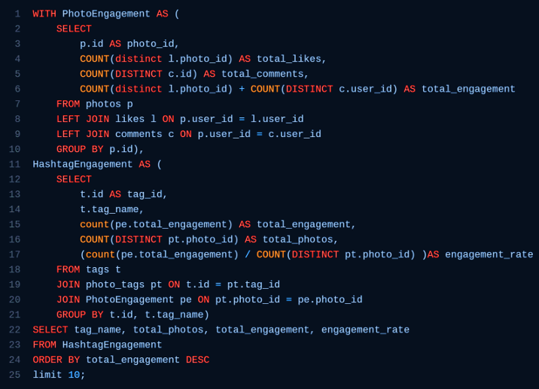

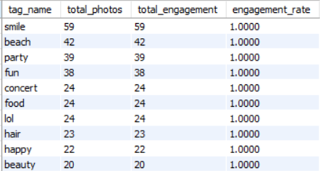

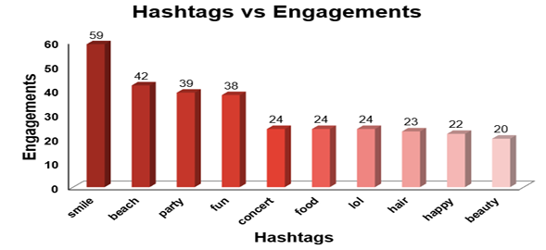

INSIGHTS:

- Top-Performing Hashtags Identified: Hashtags such as #smile, #beach, and #party consistently appeared in posts with the highest number of likes and comments, indicating strong audience engagement.

- Engagement Rate as a Key Metric: Calculating the engagement rate using total likes and comments per hashtag usage helped identify which hashtags truly resonate with users, beyond just frequency of use.

- Trending Tag Themes: The most effective hashtags are often linked to emotional or lifestyle themes, suggesting that users engage more with content that reflects positivity, fun, and everyday experiences.

RECOMMENDATIONS:

- Promote High-Engagement Hashtags: Highlight the most engaging hashtags across the platform to encourage more users to include them in their posts. This can be done through recommendations while posting or showcasing them on a trending tags list.

- Hashtag-Driven Content Strategy: Create weekly challenges or content prompts around popular hashtags to boost participation. Encourage creators and communities to engage with these specific tags to drive visibility and engagement.

- Targeted Ad Campaigns: Use high-engagement hashtags as part of ad targeting and content strategy. Aligning ads with popular tags will improve their relevance and effectiveness with your audience.

- Regular Hashtag Performance Tracking: Monitor the usage and engagement of hashtags periodically to detect shifts in trends and identify new opportunities for engagement and content alignment.

- Develop a Hashtag Performance Dashboard: Build a dashboard in Excel or any BI tool that tracks key metrics like total usage, total likes, total comments, and engagement rate of each hashtag over time to support ongoing decision-making.

- Are there any patterns or trends in user engagement based on demographics (age, location, gender) or posting times? How can these insights inform targeted marketing campaigns?

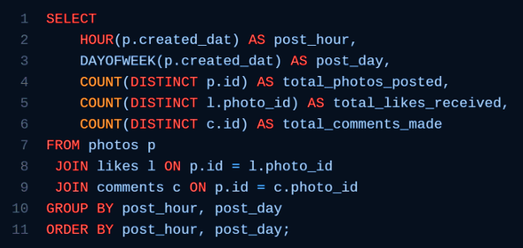

For this I constructed a Query to check the Total photos posted, total likes received on that photo, and total comments on those photos at particular time and days of week.

Which gave us the following output.

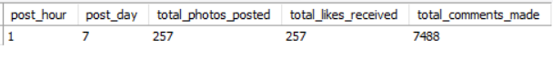

INSIGHTS:

- Mid-Week Engagement Peak: Analysis revealed that posts made on Wednesdays receive the highest number of responses and engagements, indicating a consistent midweek activity spike among users.

- Timing and Engagement Correlation: There is a noticeable pattern between the day of posting and user engagement levels, which suggests that timing plays a significant role in maximizing content visibility and interaction.

- Demographic-Based Patterns: Preliminary insights suggest engagement varies across different times and may also be influenced by user demographics such as age group or activity patterns throughout the week.

RECOMMENDATIONS:

a) Optimize Posting Schedule: Schedule high-priority content, campaigns, or
announcements on Wednesdays to leverage peak engagement periods. Use scheduling tools to automate consistent mid-week posting.

b) Launch Time-Sensitive Campaigns: Plan promotional offers or marketing pushes midweek when user attention and responsiveness are highest, ensuring better reach and interaction.

c) Conduct Deeper Time-of-Day Analysis: Further analyse time-of-day trends (e.g., morning, afternoon, evening) to refine scheduling strategies and identify optimal hours for different audience segments.

d) Implement Targeted Campaigns: Use the engagement timing data to run targeted ad campaigns that align with the online behaviour of different demographic groups, increasing campaign effectiveness.

e) Enhance Personalization Based on Timing: Develop and recommend content that aligns with users' engagement windows—both in timing and in format. For instance, shorter, more visual content for high-traffic mid-week times.

- Based on follower counts and engagement rates, which users would be ideal candidates for influencer marketing campaigns? How would you approach and collaborate with these influencers?



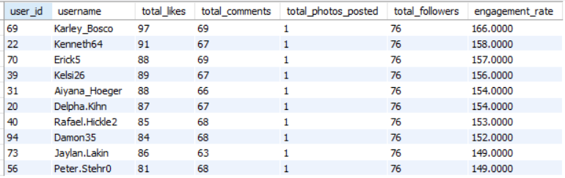

INSIGHTS:

- Top Influencers Identified: By analyzing user data, the top 10 users with both high engagement rates and large follower bases were identified. These users consistently generate high levels of interaction on their content, making them strong candidates for influencer marketing.

- Engagement as a Core Metric: Engagement metrics (likes and comments) combined with follower count provided a balanced view of a user’s influence—focusing not just on reach, but also on audience interaction.

- Effective Use of CTEs for Filtering: The use of common table expressions (CTEs) helped isolate users with large followings first, and then filter further by engagement metrics, ensuring that only impactful and relevant users were selected.

RECOMMENDATIONS:

- Identify Potential Influencers: Target users who combine strong follower bases with high engagement rates. Focus on those whose content style, tone, and audience align with your brand's identity and goals.

- Develop a Clear Collaboration Strategy: Approach identified influencers with a compelling offer—this could include sponsored posts, early access to products, branded collaborations, or co-created content. Ensure that the value exchange is clear and mutually beneficial.

- Foster Long-Term Partnerships: Build sustained relationships by offering roles like brand ambassadors or affiliate partners, rather than relying solely on one-off campaigns. Long-term collaboration enhances authenticity and trust among their followers.

- Monitor and Measure Impact: After onboarding influencers, track the performance of their posts using engagement metrics and conversion data to measure the return on investment and guide future partnership strategies.

- Maintain an Influencer Database: Create and maintain a database or dashboard of top influencers, tracking their engagement trends, audience demographics, and past collaboration outcomes for easier future targeting.

- Based on user behavior and engagement data, how would you segment the user base for targeted marketing campaigns or personalized recommendations?

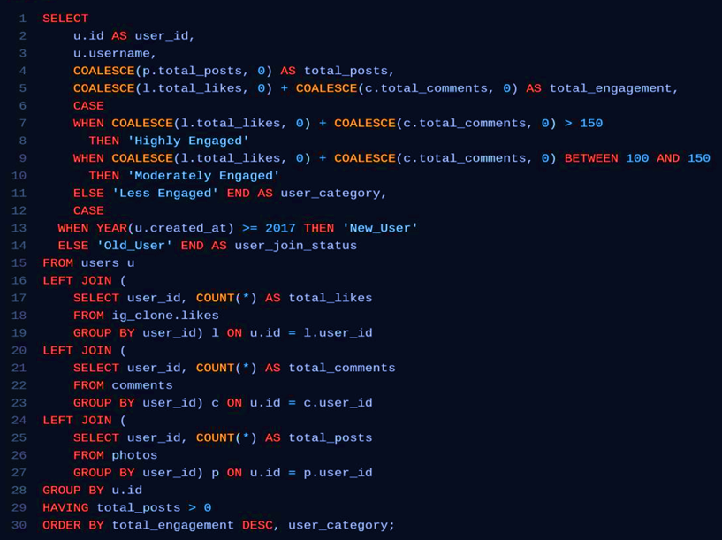

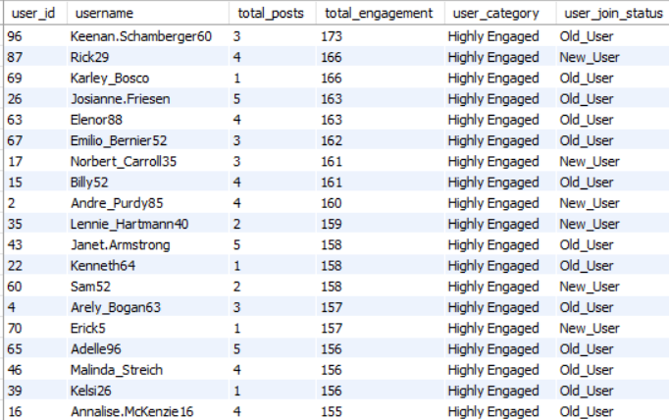
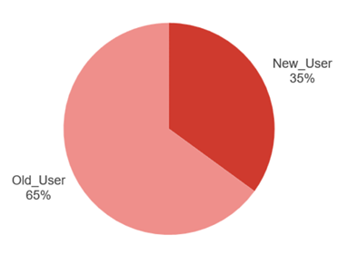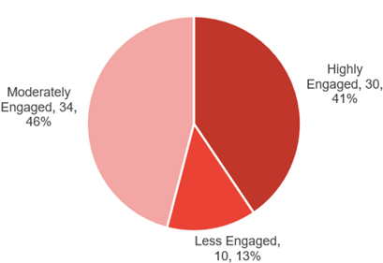

INSIGHTS:

a) User Segmentation Based on Engagement: Users were classified into three primary segments:
• Highly Engaged: Users with more than 150 total engagements
• Moderately Engaged: Users with 100–150 total engagements
• Less Engaged: Users with fewer than 100 total engagements
This categorization helps identify how active and involved users are on the
platform.

b) Time-Based User Classification: Users were further divided based on account age:
• New Users: Accounts created in or after 2017
• Old Users: Accounts created before 2017
This additional segmentation reveals trends in engagement across user cohorts and can be useful for lifecycle marketing.

c) Effective Use of SQL Techniques: By leveraging CTEs, JOINs, and CASE
statements, you efficiently calculated engagement levels and applied classification rules, resulting in a clean, actionable dataset.

RECOMMENDATIONS:

- Refine Segmentation Strategy: Continue using data-driven segmentation by combining behavioural data (likes, comments) with temporal data (account age) to create a multi-dimensional view of your user base.

- Targeted Marketing by Segment:
- Highly Engaged Users: Reward with exclusive content, loyalty perks, or early access to features.
- Moderately Engaged Users: Encourage more activity with personalized nudges or targeted content recommendations.
- Less Engaged Users: Re-engagement campaigns such as email prompts, suggested content, or incentives can be used to revive interest.

c) Lifecycle Marketing Based on Account Age:
- New Users: Focus on onboarding, feature discovery, and early engagement.
- Old Users: Promote retention strategies, offer nostalgic content, or loyalty rewards recognizing long-term commitment.

- Personalized User Experiences: Use segment-based insights to personalize feed content, email communication, and app notifications, improving user satisfaction and platform stickiness.

- Track Performance Over Time: Monitor how users move between segments (e.g., from moderately engaged to highly engaged) to evaluate the effectiveness of your engagement strategies.

- If data on ad campaigns (impressions, clicks, conversions) is available, how would you measure their effectiveness and optimize future campaigns?

To measure the effectiveness of ad campaigns, it's important to analyse various metrics that provide insights into how well the campaign is performing in reaching and engaging the target audience. The aim is to not only evaluate the campaign's performance but also to use this information to optimize future campaigns for better results.

Measuring Effectiveness:

● Impressions: High impressions indicate good visibility. However, impressions alone don't tell the full story of effectiveness. They need to be analysed in conjunction with other metrics like clicks and conversions.

● Clicks: A higher Click Rate suggests that the ad content, creative, and targeting are compelling and relevant to the audience. Low Click Rate might indicate that the ad is not engaging or that it is being shown to the wrong audience.

● Conversion Rate: A high conversion rate indicates that not only are users interested enough to click the ad, but they are also motivated to take further action. A low conversion rate could point to issues with the landing page, the offer, or the overall user experience.

● Engagement Metrics: High engagement indicates that the ad content resonates with the audience, which can increase brand awareness and loyalty, even if it doesn't immediately lead to conversions.

Optimizing Future Campaigns:

● Testing: Test different versions of your ad (e.g., headlines, images, calls to action) to see which performs better. Use the results to refine future ads. If one version of an ad has a higher Click Rates or conversion rate, focus more resources on that approach.

● Refining Targeting: Analyse which audience segments (age, gender, location, interests) are responding best to your ads. Adjust targeting to focus on high-performing segments. If data shows that a particular demographic converts at a higher rate, allocate more of your ad budget towards reaching this group.

● Optimizing Ad Platforms: Evaluate which platforms or ad placements (e.g., social media, search engines, websites) are generating the best results. If ads perform better on a particular platform or time of day, shift your ad spend to maximize visibility during those peak times or locations.

● Utilizing Retargeting: Use retargeting to show ads to users who have previously interacted with your brand but didn’t convert. If data shows a significant drop-off after the initial interaction, retarget those users with personalized ads to encourage them to complete the conversion.

● Continuous Monitoring and Iteration: Regularly monitor campaign performance and be ready to make adjustments as needed. If you notice a decline in performance metrics, don’t hesitate to tweak your ads, targeting, or budget in real-time.

By systematically measuring the effectiveness of our ad campaigns using these metrics and strategies, we can make data-driven decisions to optimize future campaigns, ensuring higher engagement, conversions, and overall return on investment.

- How can you use user activity data to identify potential brand ambassadors or advocates who could help promote Instagram's initiatives or events?

We have the categories Highly Engaged, Moderately Engaged and Less Engaged so now we will see which of these users are highly engaged, have more followers and regularly posting, we will prioritize them as potential brand ambassadors or advocates.

Here's how we can leverage user activity data for this purpose:

● Identify Highly Engaged Users: Track users with a consistently high engagement rate, which includes frequent likes, comments, shares, and story interactions. These users are actively involved with the content and show genuine interest in the brand. Identify users who frequently share the brand’s content or mention the brand in their posts and stories. Sharing indicates that they are not only engaging but also helping to amplify the brand’s message.
● Analyse Influence and Reach: Look for users with a significant number of followers, as they have the potential to reach a larger audience. While follower count alone isn't sufficient, it’s a good starting point. Identify whether the user is already an influencer within a relevant niche. Influencers who align with the brand’s values can effectively promote initiatives or events.
● Monitor Content Quality and Alignment with Brand Values: Review the type of content the user regularly posts. Are they creating content that aligns with the brand’s image and values? For instance, if Instagram is promoting a wellness event, users who frequently post about health, fitness, or mindfulness could be ideal ambassadors. Look for users who demonstrate creativity and originality in their posts. High-quality, visually appealing content can enhance the brand’s image when shared.
● Track Loyalty and Long-Term Engagement: Identify users who have been consistently engaging with the brand over an extended period. Long-term engagement indicates loyalty and a deeper connection to the brand. Look for users who have already advocated for the brand in the past without any incentive. Their genuine support makes them strong candidates for formal ambassador roles.
● Evaluate Potential for Authentic Advocacy: Assess whether the user’s interactions with the brand appear genuine or if they are merely engaging for incentives (e.g., giveaways). Authenticity is key to effective brand ambassadorship. Analyse any user-generated content where the individual shares personal experiences with the brand’s products or services. Testimonials can indicate a strong connection to the brand, making them more credible as advocates.
● Reach Out and Engage Potential Ambassadors: Engage with these users directly through comments, likes, or direct messages. This can help establish a relationship and assess their willingness to collaborate. Offer them opportunities to participate in exclusive events, beta tests, or product launches. This not only strengthens the relationship but also provides a platform for them to naturally promote the brand.

- How would you approach this problem, if the objective and subjective questions weren't given?

Well certainly the Objective and Subjective questions were very helpful as they provided the outline and better understanding of the problems and how to reach the solutions. But if the case was that the Objective and Subjective questions were not given then I would have followed a certain approach with certain steps to analyse and come up with insights from the given data.

The Approach and the steps in it would be as follows:

● Problem Identification: I would start by understanding the goals and desired output of the analysis, whether we are optimizing user engagement, increasing retention or identifying potential influencers. After analysing all this I would set up my plan and course of action on how I am going to manipulate the data.
● Data Exploration: Conduct a reading analysis to understand the data structure, distribution, and any initial trends or faulty data and whether any direct conclusion can be made with the raw data or not.
● Data Cleaning and validation: I would start working on the data and my first step would be to check for null values and duplicates in all the tables and if found then rectify them. So that data can be ready to work on.
● Trend Formation: Develop hypotheses based on observed trends or known
business goals. For example, "Users who engage more frequently are more likely to retain." Then check for their followers' activity and various other things from which we can come to conclusion whether to work with them or not.
● Data-Driven Solutions: Then finally I would use SQL operations on the data to check whether my overview analysis stands correct or not and if not, then what are the trends and how the current trends are different and varying from the desired results.
● Insights of Current Scenario: At last, I would take all the outputs from the SQL operations and create a Report of current scenario and how much we need to work in which aspects. The analysis will give us the aspects in which we are lacking behind, so that the management can take proper actions to rectify them.

- Assuming there's a "User_Interactions" table tracking user engagements, how can you update the "Engagement_Type" column to change all instances of "Like" to "Heart" to align with Instagram's terminology?
For this problem first I created a new Table User_Interactions with the following Query.
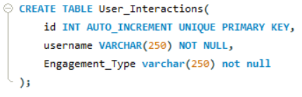
After creating the User_Interaction table then I entered values in the table taking from the original table data.
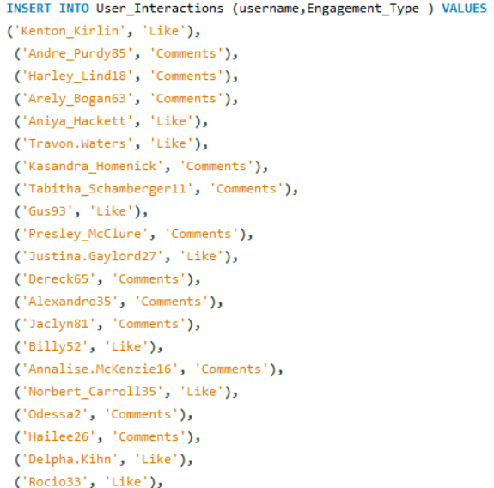
Finally for updating the values in the table User_Interaction which was the original problem statement I constructed the following SQL Query
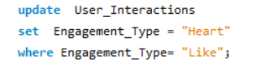
From the above query I got the desired output updating the "Engagement_Type" column to change all instances of "Like" to "Heart" to align with Instagram's terminology.
